Name____________________________________________Block/Day_________ U4 LE2 Simmons/ Merritt
People |  | “Arm Wrestling for World Dominance”  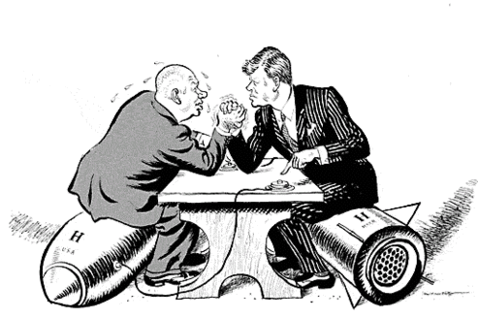  Source  Leslie Gilbert Illingworth, Daily Post, October 1962
Objects | Circle all objects you see on the political cartoon.
Symbolism

Text | “Arm Wrestling for World Dominance”
What was the author trying to communicate about the Cold War?

Current Event News Clips
https://www.cbsnews.com/live-news/trump-kim-conclude-historic-summit-in-singapore-live-updates-today-2018-06-12-live-updates/ (4:59)
https://www.cnbc.com/2019/03/08/trump-disappointed-by-activity-at-north-korea-missile-sites.html (second Clip down) (4:15)
Article (if time permits) https://www.bbc.co.uk/newsround/47398755

What are the most important details mentioned in this news press regarding US and North Korean Relations?
What guidelines (rules) should drive US foreign policy with North Korea?

Develop a scholarly focus question that would spark the interest of community members to discuss the topic

